II B. Tech. I Semester Regular Examinations – November, 2023
OBJECT ORIENTED PROGRAMMING THROUGH JAVA
(CSE/CSE(CS))
Time: 150 Min Max. Marks: 80M

SECTION – A
Answer all Four questions 4×10M=40M

- a) Explain the types of inheritance in Java. Is JAVA supports multiple inheritance Justify your answer. [2M]
b) Describe the situations of using super keyword and this keyword in Java. Provide examples to illustrate its usage in different scenarios related to inheritance. [2M]
c) Build a comprehensive Smart TV system, which aim to create a class that encapsulates the functionality of a Smart TV with the following capabilities using multiple interfaces [3M]
- Displayable - Defines methods for displaying content on the screen.
- Connectable - Specifies methods related to connecting to external devices.
- Streamable - Encompasses methods for streaming online content.
d) Create a three-level hierarchy of exceptions. Now create a base-class A with a method that throws an exception at the base of your hierarchy. Inherit B from A and override the method so it throws an exception at level two of your hierarchy. Repeat by inheriting class C from B. In main(), create an object for a C and up cast it to A, by calling the overriding method. [3M]
- Design a code snippet for online movie ticket booking application. The application allows users to search for a movie, view movie details, and book tickets. The requirements of online movie ticket booking application are as follows:
- Define Exception. Discuss the procedure followed for exception handling. [2M]
- Explain the concept of garbage collection in Java and its role in memory management. Describe how the Java Virtual Machine (JVM) identifies and collects objects that are no longer reachable. Compare and contrast the automatic garbage collection process with manual memory management. [2M]
- Design a class named `Movie`, which represents the movie database in the application with the following attributes and methods. Attributes are: - `movieId` (int), `title` (String), `availableSeats` (int).and methods are as follows: -
- addMovie(Movie movie)`: Adds a new movie to the movie database.
- findMovieById(intmovieId) throws MovieNotFoundException`: Searches for a movie by its `movieId` in the movie database. If the movie is not found, throw the `MovieNotFoundException`.
- bookTicket(intmovieId, intnumOfTickets) throws TicketBookingException`: Allows users to book tickets for a specific movie identified by its `movieId`. If the movie is not found or there are insufficient available seats, throw the `TicketBookingException`. [3M]
- Create a movie database for above the class using appropriate collection famework. [3M]

- a) Design a program that demonstrates the creation of multiple threads using both the Thread class and the Runnable interface. Compare and contrast the two approaches. [2M]
b) Explain the concept of synchronization in multithreading and how to achieve it. Provide an example program where synchronization is necessary and demonstrate ts use in your program. [2M]
c) Develop a code snippet for generating set of random numbers and then determine negative even, negative odd, positive even, positive odd numbers concurrently using threads. [3M]
d) Develop pseudo code for calculating he sum of the series 1+2+3+…+100, by splitting this series in to (1+3+5+…+99) + (2+4+6+…+100). Create two threads to compute two series in parallel and print the final sum. [3M]

- Develop a program that analyses social media posts to extract valuable insights. The program should use Java's Collection Framework to efficiently process and analyse a collection of social media posts. Here are the tasks to be implemented:
a) Create a class SocialMediaPost with attributes: post ID (integer), content (string), author (string), timestamp (date/time), and likes (integer). [2M]
b) Implement a system using appropriate collection classes (e.g., ArrayList or HashMap) to store SocialMediaPost objects and with the three methods such as: add posts to the collection, remove posts by post ID, and display the contents of the collection. [3M]
c) Calculate and display the total number of likes received by all posts. [2M]
d) Present statistics such as the average number of likes per post and the most active authors by ensuring that it should handle concurrency issues when multiple users access and modify the post collection. [3M]
SECTION - B
Answer all Two questions 2×20M=40M

- An Institute plans to store student data in softcopy format for easy access and to minimize physical maintenance.
- Discuss the concept of access control modifiers (public, private, protected, default) in Java. Describe when and why you would use each of these modifiers in your Student class. [3M]
- Create a package called Marks. Store all 10-student information in that package with 6 subjects marks, roll nos, student names, section information and campus information. Create a class that student can see his/her marks with percentage and information based on his registration number. If registration number is not found exception should be raised. [4M]
- Compare and contrast the ArrayList and LinkedList classes in Java collections. Outline the fundamental differences between these two data structures and highlight scenarios where each would be more suitable than the other. Support your explanation with relevant examples. [4M]
- Create a Java application to analyze the word occurrences in a given text and provide word frequency statistics. Your application should take a single input string representing the text. Implement a function countWordOccurrences that counts how often each word occurs in the text. The function should then return a string containing word frequency entries in the format "word - frequency". [4M]
- Discuss the advantages and disadvantages of using built-in exceptions versus user-defined exceptions in your Java programs. Identify what types of exceptions may arise in the above scenario and specify the logic for handling those exceptions.[5M]

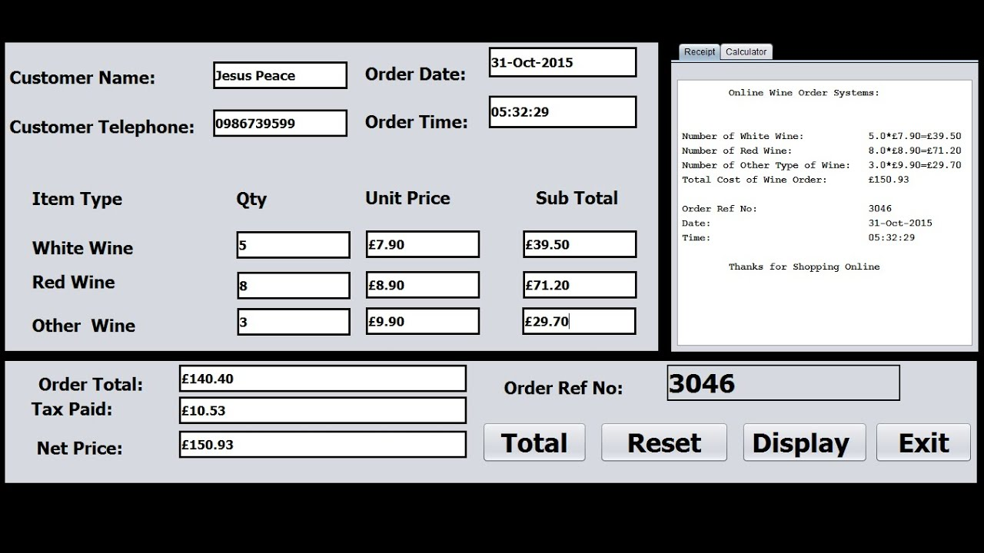

a) Define and discuss the role of event sources in Swing. Provide examples of Swing components that act as event sources to generate events. [4M]
b) Discuss best practices for managing event handling in a Swing application,ding strategies for efficient event management and maintaining a responsive user interface. [4M]
- Develop a basic quiz interface using Java Swing. Create a graphical interface that displays a question and its multiple-choice options. The interface should allow the user to select an answer and proceed to the next question when the "Next" button is clicked. The interface should consist of the following elements: [5M]
- A JLabel to display the question.
- Four JRadioButton options for the user to select an answer.
- A JButton labeled "Next" to proceed to the next question.

d) Create the above design page in java with using java swings concepts? [7M]

